**Lab – Python 3: Add content to Dungeons and Dragons game**

Concepts for this lab:

Work as a pair to experience pair programming  
Modify an existing program (very common)  
Create modules  
Call modules   
Call modules that are stored in a different file

Attached to this assignment is 2 versions of a Dungeons and Dragons game.

Version 1 - game_10.py

Version 2 – game_10_with_design.py

The first version is a simple game with few choices and very little interaction. The second adds ASCII Art Graphics (see article linked in the Resources Folder) and more conversation choices. In the second file it suggest changes you could make to the game.

####################################################################  
 # ACTIVITIES  
 # Read some of the best practices when writing Python code  
 # http://legacy.python.org/dev/peps/pep-0008/  
 # Main thing is if you are using tabs, make sure it's 4-spaces,  
 # most editors will convert it (check preferences/settings).  
 #  
 # Modify the code  
 # - add taunting the guard or talking  
 # - sword fight with the guard, and keep track of health points (HP)  
 # - puzzles like 1+2 during an encounter  
 # - modifiy blissful_ignorance_of_illusion_room()'s if statement  
 # so it takes into account player typing "right" or "guard"  
 # Hint: Add another elif before the else statement  
 #  
 # So many if statements, this can be made simpler and easier to   
 # maintain by using Finite State Machine (FSM)  
 # You can find info about it, but it will mainly be touching   
 # object-orient programming, which is another lesson for another day.  
 # #####################################################################

You and your partner are going to choose to add another room to the game (based on color). The rooms in this dungeon and dragons game are similar to challenges you will encounter in the typical Capture the Flag game. (Think about Kringlecon)

Procedure

1. Choose a color and claim it in the wiki. Put the name of both programmers by the color. Only one computer science student is allowed per team
2. Download both programs
3. Execute them in your python environment or in Python Anywhere to see what happens
4. Play the game until you become familiar with the choices
5. Write a description of what you are planning to add to the game  
   Example:  
   My partner and I are going to add a purple room. In the room is a massive vat of grape jelly. The player must choose to eat the jelly , swim through the jelly, transform the jelly, or leave the room. If they eat the jelly (using a glutton spell) they will lose10 health points (HP) from a stomach ache but find the treasure at the bottom of the vat. If they choose to swim across the jelly, they lose 5 HP because they are all sticky, and gain no treasure. If they choose to transform the jelly, they get more choices. They can transform the jelly into peanut butter and jelly sandwiches, which also reveals the treasure on the bottom of the vat. They can eat some of the sandwiches and gain HP. They can transform the jelly into a frozen grape lake and skate across. The keeper of the vat will award them style points for skating and gift them something more valuable than treasure.
6. Create a python module to print an ASCII art representation of something in the room you are creating.   
   Example:  
   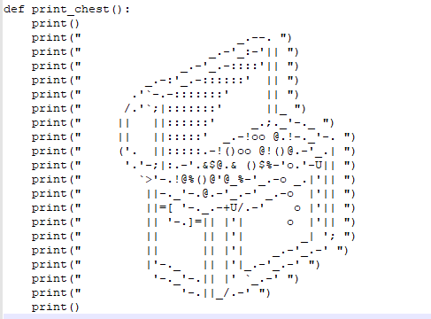
7. Create a python module that makes the player experience what you described. Follow the template attached to the assignment room.py. Name your python program room_*color*.py  
   The template has 3 sections: Actions, characters, and Rooms. Add your content appropriately as described in the comments of the template
8. Share your Python program on Python Anywhere
9. Turn in your description in Word document on Blackboard

Rubric

Description – 5 pts

Module with Ascii art, room, and action 30 pts

Program runs with all choices: 5 pts

Turned in on Python anywhere: 5 pts

Correctly claimed in the wiki and named correctly: 5 pts  
Creativity: 10 pts